The 7 Steps to Buy a Building Sign

There are many options and choices of signs to choose from. All signs are custom made to suit your particular need. We can help you make the right choices, but we do need to obtain some information from you to enable the quote process.
Information we need to enable us to quote:
- The city and full address location
- Where on the building do you wish to have the sign – which elevation & location on the wall first story or top of building? Send a photo if you can.
- Do you prefer an illuminated sign or a non-illuminated sign?
- Exact text and logo. Send us a file of your business logo (business name, brand identity, icon)
- Are you the building owner?
  - If yes, obtain the sign program from the Association, if ones exists
  - If not, have you contacted the landlord, property manager or Association to determine if your lease allows you to have a sign on the building?
- Is there a sign on the wall that needs to be removed?
- Is there a timeline you are trying to meet?

What we can provide you with:
- Material options and size recommendations to provide with the most optimum solution
- Price quotation
- Lead time.

Sign Programs, Sign Permits and Landlord approval
- All exterior building signs require a permit
- You need to determine if there is a sign program documented for your building. If the property owner, landlord or Association cannot help you or you are not sure then call the city. A quick phone call to city hall, ask for Planning Department, speak to a Planner, let them know you want to put a sign on your building, provide the address location and ask them to send you either the sign program or the sign criteria.
- Zoning regulations and Sign Programs dictate the type and size of signs. Cities manage zoning and sign criteria, landlords, property managers and Associations manage sign programs.
- Send us all this information so that we may design and quote pricing for your sign within all the correct guidelines to submit for approval.
- Exterior signs take much longer to process than most interior signs due to the need for landlord approvals, city permits and fabrication times; it is important you plan ahead and know that signs of this nature may take 6-8 weeks to complete. Caliber is a licensed contractor and always follows city code.

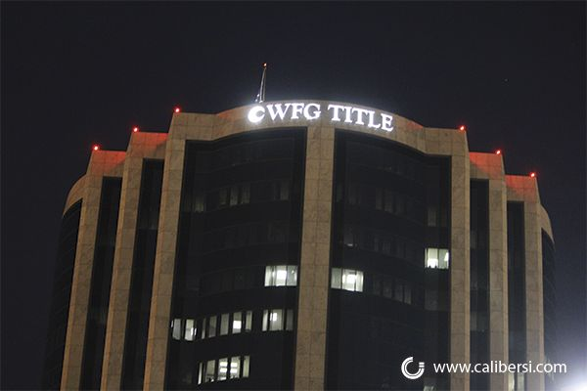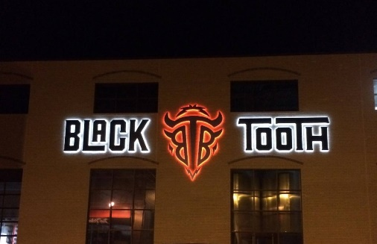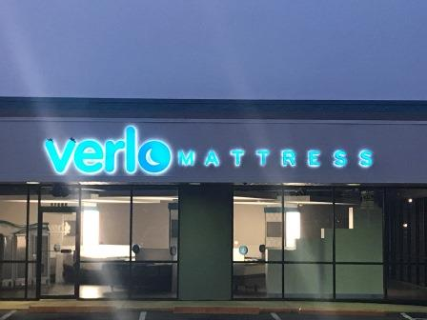
Face-Lit Sign | Halo-Lit Sign | Dual-Lit Sign

Pro Tips:
- Sign programs – a pre-approved document registered with the city that outlines in detail sign specifications and drawings approved for your building or building complex. Any licensed sign company must abide by the criteria in these documents. Sign programs determine and control the height and length of the sign, the colors and materials, as well as allowable sign locations on the building and the number of signs on any specific building elevation
- Illuminated signs require electrical power to operate the sign just like a light bulb on a wall requires electrical wiring inside the wall as well as a switch. It is the client’s responsibility to provide the electrical wiring installation and a timer control not the sign company. The electrical must be in place before the sign is installed
- Material, non-illuminated - most economical material for non-illuminated dimensional exterior building sign letters and logos is foam with acrylic faces. Dimensional depths are typically 2”
- Materials, illuminated - made from aluminum and are called channel letters. They are fabricated by hand and contain low voltage LEDs. Signs lighted through the front faces are called ‘front lit’. Signs lit with a halo effect at the back of the sign letters shining onto the wall are called ‘reverse lit’ or ‘halo lit’. Signs that combine both front lit and halo lit are called ‘dual lit’.
- Price differences between different types of signs:
  - Illuminated channel letters versus non-illuminated channel letters = illuminated more expensive by +20%
  - Halo lit versus face lit = Halo lit more expensive by +25%
  - Dual lit versus face lit = Dual lit more expensive by +35%
  - Non-illuminated channel letters versus foam/acrylic = channel letters more expensive by +100%
- Typical life span of signs (non-south facing walls)
  - Foam/acrylic faced letters = 5 to 8 years
  - Foam/acrylic faced letters with stucco painted edges = 8 to 12 years
  - Foam/aluminum painted faced letters with stucco painted edges = 10 to 15 years
  - Illuminated channel letters with acrylic faces (light colors) = 8 to 12 years
  - Illuminated channel letters with painted faces and halo lit = 10 to 20 years
- Prices subject to site survey - before we install the sign and at the time of quotation, it is important for us to know the access below the sign location for vehicles or ladders. For instance, is it possible to get direct access by bucket truck? Is there a parking lot directly below? Are we able to “cone off” parking spaces? Are there plants and shrubs directly below, can we reach by ladder, is there a slope on the ground below? Is the asphalt surface more than 10’ from the building, are there trees in the way, how high from the ground will the sign be? For tall buildings, can we get access from the roof via staging or do we need a crane? For interior ceiling connections of electrical wiring, do we need access to an office suite belonging to another tenant or maybe a conference room that may need meeting re-scheduled? Is there an on-site Property Management company that requires liability insurance documents submitting?
- Obtain a permit from the city - you must have a valid business license, a certificate of occupancy and a building permit for any completed tenant improvements (TI)

PROCESS TIME FROM QUOTE REQUEST TO INSTALLATION
Caliber designs a sign to fit your building and to meet city regulations. Days quoted below are working days.
- Receive Quotation (depends if survey required) = 2+ days
- Receive your comments/edits/approval = 1+ day
- Receive and process your down payment deposit to open a work order
- Provision of our drawing proof for review and signed written landlord approval = 2+ days
- Submission of city permitting and permit approval (depends on city) = 1 to 10 days
- Fabrication after city permitting approval = 15 to 25 days
- Installation = 1 day
  - Balance payment upon completion of installation
Final Payment

Installation
(1 day)
Fabrication
(15-25 days)
City Permit
(1-10 days)
Final Proof/LL Approval
(2+ days)
Deposit
(1 day)
Edits/Signed Approval
(1+ day)
Quote*
(2+ day)

*Survey may be required
For more information, check out our Price Guide for guidance on requirements, options, lead times and prices.

Questions? Call (949) 748-1070 or email customercare@calibersi.com

